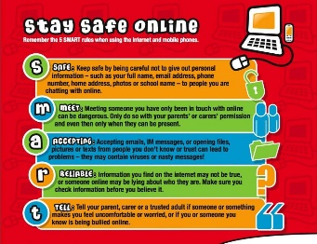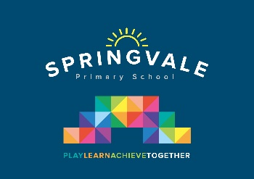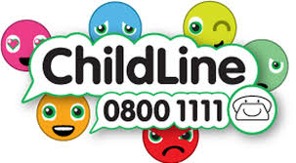

|  |  |
| --- | --- |
| **Learning Project WEEK 6- Food** | |
| **Age Range:** EYFS  FS2 The Curious Cubs | |
| **Weekly Maths Tasks (Aim to do 1 per day)** | **Weekly Reading Tasks (Aim to do 1 per day)** |
| * Working on [Numbots](https://numbots.com) - your child will have an individual login to access this. * This week learn about number 16. Add number 16 to the 0 – 15 digit cards you made last week. Ask a grown up to hide them around your room, house or garden. You could ask someone to tell you a number to find. Can you remember what the number looks like and find it? * Play the Numberblocks add and subtract [game](https://www.bbc.co.uk/cbeebies/puzzles/numberblocks-number-magic-adding-and-subtracting?collection=numbers-and-letters). * Use wooden blocks or lego to practice addition using counting on. Make a 1-3 dice by adapting it with sticky labels. Roll the dice and collect 1, 2 or 3 blocks to add to their tower .If they are ready, encourage them to count on, as they add their cubes each time. How high can they build their tower before it topples? * Explore weighing and measuring food on the kitchen scales. Ask, what happens as you place more on the scales? * Look for numerals on packaging you find around the house. Can your child recognise the numerals and count out a matching amount? | * Reception age children: Children to read to parents daily. Visit Oxford Owl for free eBooks that link to your child’s book band. You can create a [free account](https://www.oxfordowl.co.uk/for-home).   Complete the linked Play activities for each book.   * Practise reading your tricky Red Words. If you need a new card please email school and we will make sure you get the next one. * Look at recipe books and food magazines. Encourage your child to use their phonics knowledge to decode the ingredients list. Select a recipe and make this together. Encourage your child to read the labels on packaging to figure out which ingredient it is. |
| **Weekly Phonics Tasks (Aim to do 1 per day)** | **Weekly Writing Tasks (Aim to do 1 per day)** |
| Our children are all in very different places for learning sounds. Please ask your child which adult they work with for phonics and focus on these sounds  Mrs Cliffe/Mrs Honey and Mrs Parr  Sounds Re-cap ch sh th ng nk  Mrs Slack/Mrs Gale/Mrs Evans  Sound of the week: ar (start the car)  Read and spell words such as , car, farm, dark, park, jar, shark   * Go to newphonicsplay.co.uk and play Grab a Giggling Grapheme, to practise ch sh th ng * Go to ictgames.co.uk and play Forest Phonics to practise the ar sound * Pour flour, rice or lentils into a shallow tray or plate. Say a word containing the sound of the week, ‘wink’ for eg or ‘car’, and ask your child to ‘write it’ in the food using their finger. | * Practice forming the letters **b p h** * Using recipes from books as a guide, ask your child to create their own recipe for their dream meal. They could draw out the ingredients and label them and draw the finished meal. Some children may be able to write a few short sentences as instructions. * Look at a range of different packages found around the kitchen. Discuss with your child what makes it stand out to a customer. Support them to design a package for a treat of their choice.   **When you are supporting your child remember to encourage them to write independently and use their phonic knowledge. At this age we practise learning how to spell correctly the red tricky words. Encourage your child to use their red word cards to help with this.** |
| **Learning Project - to be done throughout the week** | |
| **The project this week aims to provide opportunities for your child to learn more food. Learning may focus on where different foods originate from, what makes a healthy meal, opportunities to cook etc.**   * **Healthy/ Unhealthy-**    + Provide your child with a selection of items from your kitchen cupboards. Can they sort them into things that are healthy and unhealthy? Discuss why the food is good for you or bad for you. Look at the [Eatwell plate](https://www.nhs.uk/live-well/eat-well/the-eatwell-guide/) to help figure out which foods they should eat a lot of or not very much of. * Discuss how exercise is an important part of staying healthy. Watch and complete a 10 minute [shake up.](https://www.nhs.uk/10-minute-shake-up/shake-ups) * **5 a day-**   + Support your child to create a food diary to record how many pieces of fruit and vegetables they eat in a day. They could write these using their phonics knowledge or draw a picture of each item. * **Create a collage-**   + Ask your child to draw out a number of fruits or vegetables, large enough to fill a piece of A4 paper. Provide them with a selection of colourful packaging. Can they cut out and collage on to their picture. * **Play shops-**   + Using toy food or old packaging, set up a food shop for your child to act out being the shopkeeper and customer. You could introduce coins to support their developing knowledge of money. Give them a notepad to use as a shopping list to encourage in the moment writing. * **Potato/ Vegetable Printing-**   + Using a selection of vegetables available in your kitchen, support your child to print and explore the shapes and patterns created:      * **Make cornflour gloop-**   + Mix cornflour with a small amount of water in a mixing bowl. It will make a slimy, stretchy mixture. Allow your child to explore the change of texture from wet to dry and the texture of the gloop. | |
| **Additional learning resources parents may wish to engage with** | |
| [**Classroom Secrets Learning Packs**](https://classroomsecrets.co.uk/free-home-learning-packs/) **-** These packs are split into different year groups and include activities linked to reading, writing, maths and practical ideas you can do around the home.  [**Twinkl**](https://www.twinkl.co.uk/offer/UKTWINKLHELPS?utm_source=promo&utm_medium=email&utm_campaign=England_coronavirus_schools_email&utm_content=offer_link) **-** to access these resources click on the link and sign up using your own email address and creating your own password. Use the offer code UKTWINKLHELPS.  [**Headteacherchat**](https://www.headteacherchat.com/post/corona-virus-free-resources-for-teachers-and-schools) - This is a blog that has links to various learning platforms. Lots of these are free to access. | |
| **#TheLearningProjects** | |